Building frame

1. Step one take the lowest holder and turn it back
2. Install red motor holder
   1. Be careful the red motor holder should be on dig anal of red one .

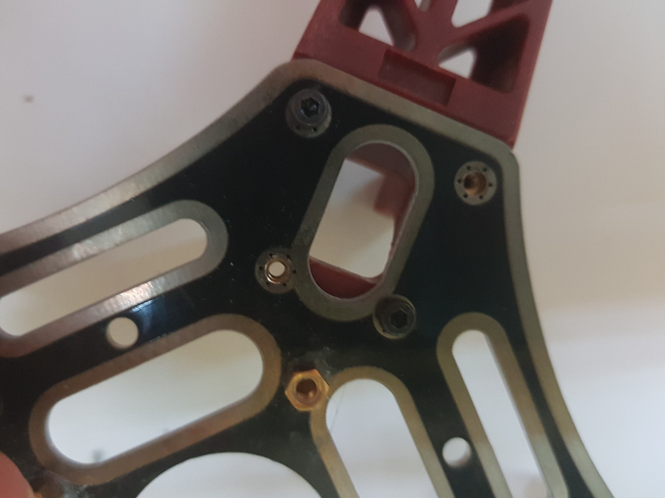

Warring . Install 4 screws and make sure that they installed correctly

Continue this for 3 left motor holders .

As result you should get :

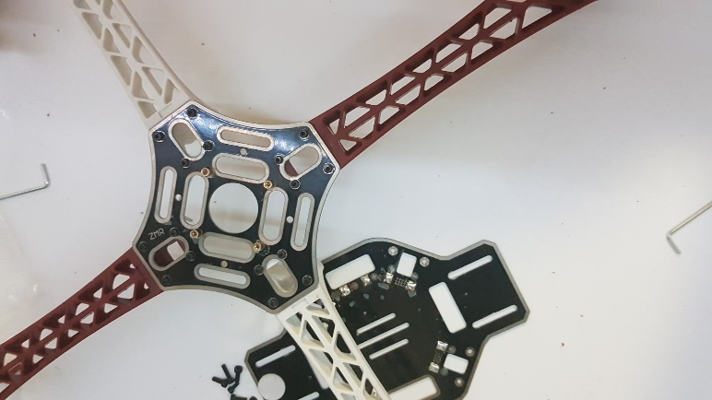

Turn back the drone:

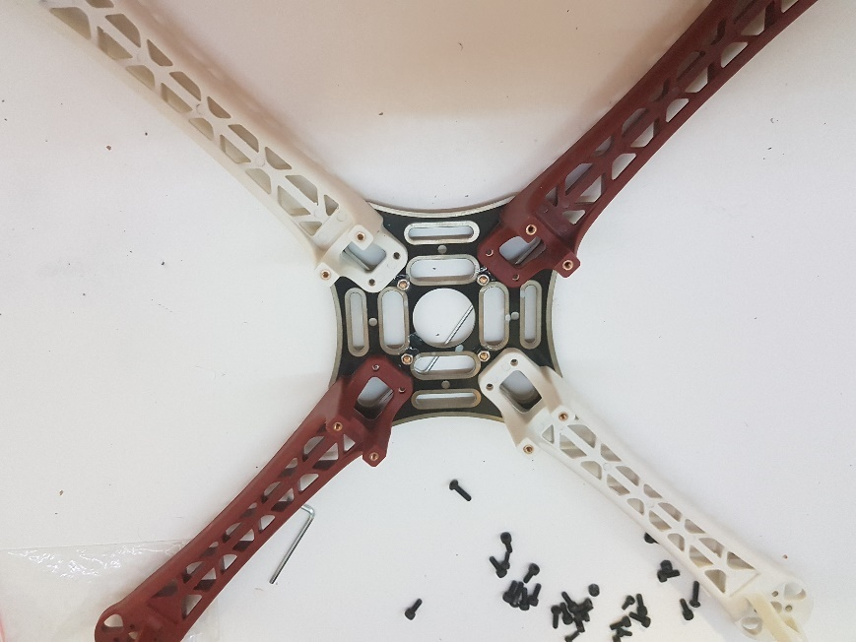

Turn over down plate and install it by 2 screws:

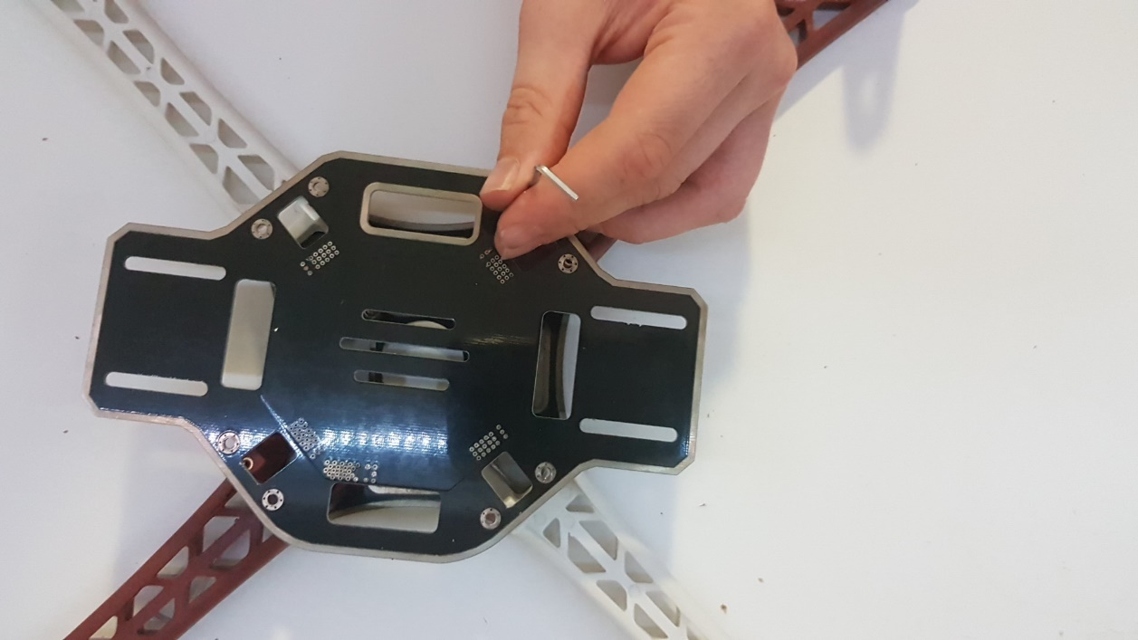

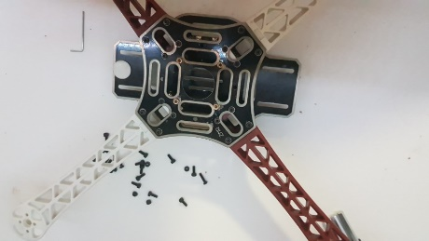Turn it back and result you should get:

Is motor install time

Check motors

Warring has different rotation so same colour screw motors should be installed diagonally

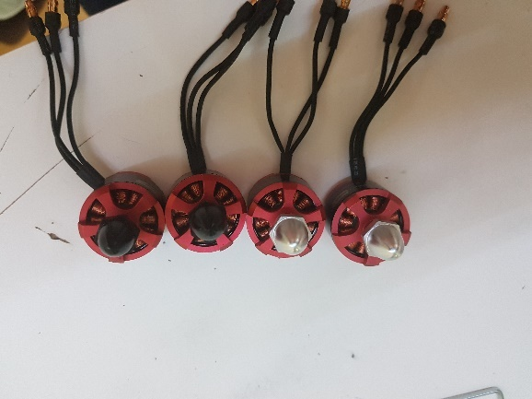

Like that:

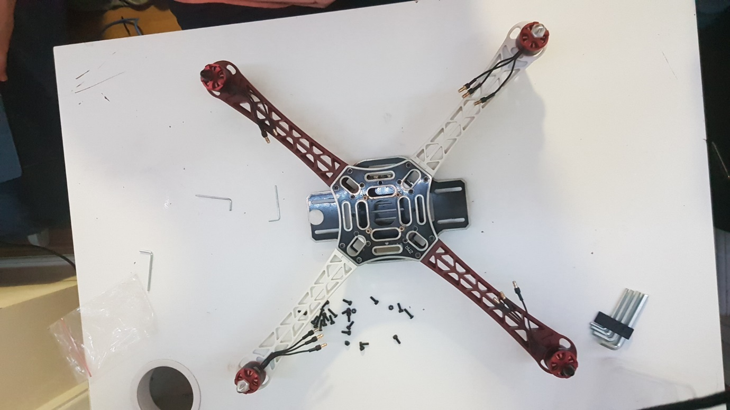

After it install by 4 screws. Be careful use correct motor length. Do not break motors:

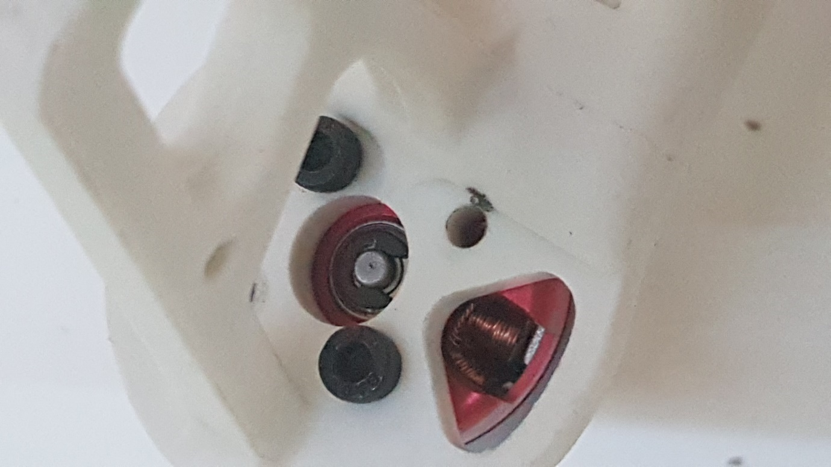

Is time to install ESC.

The rotation is different so install it now as it happened. After use setup code you fill fix it. 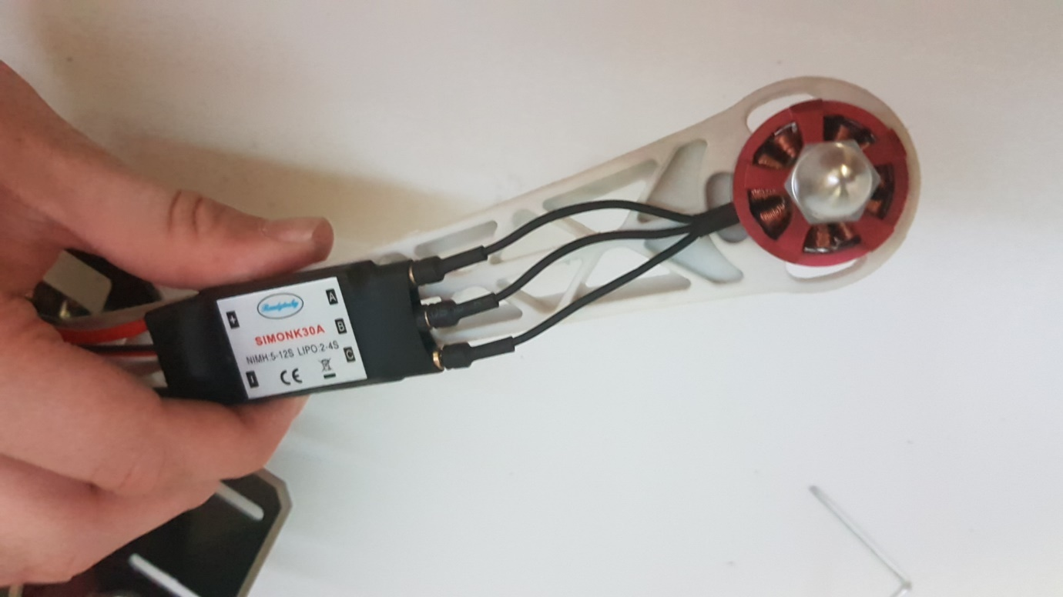

Do not forget to install it properly

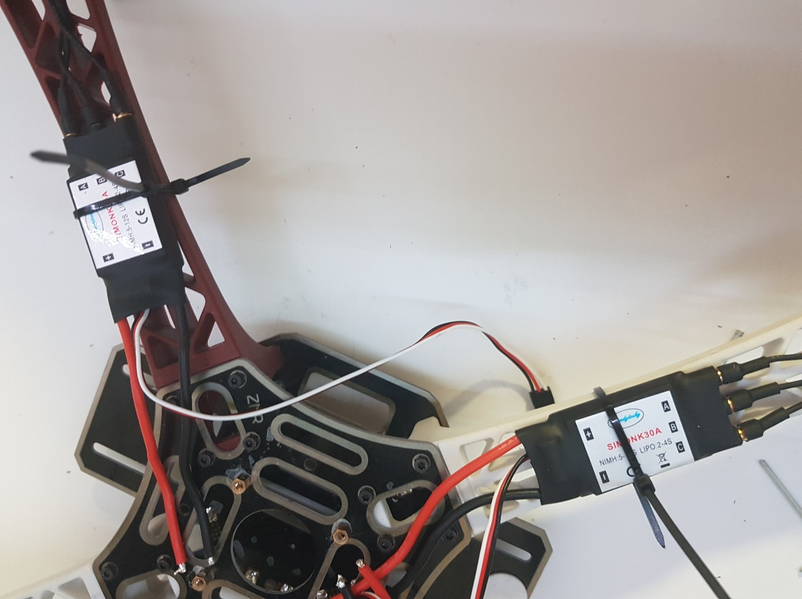

Well we are installed the minimum frame for flight. In next tutorial we will make brains.